**EXIT THE PLUGIN**

**A MINI PROJECT REPORT**

***Submitted by***

**Group : G10(B) /T18**

**Medha Goel :2210991915**

**Mehak : 2210991916**

**Mehak Budhiraja :2210991917**

**Mehak Sharma:2210991918**

***in partial fulfillment for the award of the degree of***

**BACHELEOR OF ENGINEERING**

***in***

COMPUTER SCIENCE & ENGINEERING

**CHITKARA UNIVERSITY CHANDIGARH-PATIALA NATIONAL HIGHWAY**

**RAJPURA (PATIALA) PUNJAB-140401 (INDIA)**

May – 2023

**TABLE OF CONTENTS**

|  |  |  |
| --- | --- | --- |
| **Sr no.** | **Section** | **Page no.** |
| **1.** | **Introduction** | **3** |
| **2.** | **Problem statement** | **4** |
| **3.** | **Technical details** | **5** |
| **4.** | **Key features** | **6** |
| **5.** | **Project advantages** | **7** |
| **6.** | **Results** | **8** |
| **7.** | **Conclusion** | **9** |
| **8.** | **References** | **10** |

# INTRODUCTION

* [The Exit Intent plugin extension](https://wppopupmaker.com/extensions/exit-intent-popups/?utm_campaign=documentation&utm_source=helpscout&utm_medium=doc&utm_term=146-trigger-exit-intent) displays a popup when a cursor moves outside the browser window.
* The Exit Intent extension is great for:
* Displaying a message on your eCommerce sites when visitors abandon their shopping cart.
* Improving email list signup conversions by displaying a signup form.
* Present an incentive or call-to-action to a departing visitor.
* The trigger offers multiple methods:
* **Top sensitivity**: Monitors the cursor's proximity to the top of the browser window
* **False positive delay**: Monitors the length of time that the cursor remains near or above the top of the browser.
* By default, *top sensitivity* is set to 10 pixels (px). When a cursor moves to within 10px of the top of the browser window, the trigger fires and displays a popup. The default setting is intended to limit accidental popup displays if the cursor is positioned near the top of a page.

# PROBLEM STATEMENT

* Retaining the users on the same website to provide aid for better usage and creating room for processing time.
* Providing links to the users for multiple websites based on their area of interest.
* Gathering feedback and experience of the user to enhance the website for further development and enchantment.
* Generic messages or offers fail to address the unique interests and preferences of individual users. Website owners need a solution that can deliver personalized content, recommendations, and offers precisely tailored to users' specific needs, increasing the likelihood of engagement and conversion.
* Website owners require insights and data to measure the effectiveness of their engagement strategies, understand user behavior patterns, and make data- driven decisions. A solution that provides comprehensive analytics and reporting capabilities is essential for optimizing the plugin's performance and maximizing user engagement.
* Users encounter problems when attempting to close or deactivate the plugin, resulting in prolonged application shutdown times or even system crashes.

**Technical Details**

The exit plugin is a software application that is typically built using various technologies and programming languages. The following are some of the basic technical details of the system:

1. Programming Languages: The system is typically built using programming languages such as HTML, CSS, JavaScript, and PHP.
2. User Interface: The system typically has a user-friendly interface that allows users to access and manage various features and functionalities of the system.
3. Mobile Compatibility: The system may be optimized for mobile devices, allowing users to access and manage the system using their smartphones or tablets.
4. The Exit Plugin is developed using a combination of front-end and back-end technologies. The front-end components are typically built using HTML, CSS, and JavaScript, ensuring cross-browser compatibility
5. User Behavior Analysis: The plugin incorporates machine learning algorithms and statistical techniques to analyze user behavior patterns. These algorithms track user interactions, navigation paths, time spent on different pages, and other relevant metrics to understand user preferences and interests.
6. Gamification Framework: The gamification elements of the Exit Plugin are implemented using frameworks or libraries that facilitate the creation of interactive and engaging experiences.

## Key Features

**The key features of a exit plugin include:**

* Interactive pop-ups: These pop-ups can contain engaging content, such as surveys, quizzes, or interactive elements, to grab users' attention and encourage them to interact with the website before leaving. The interactive nature of these pop-ups enhances user engagement and creates a memorable experience.
* Performance Optimization: The project focuses on optimizing the plugin's performance to ensure fast loading times and smooth operation across different devices and browsers. By employing efficient coding practices, rigorous testing, and performance optimization techniques, the plugin aims to deliver a seamless and responsive experience to users.
* Seamless Integration: The Exit Plugin is designed to seamlessly integrate with various website platforms and content management systems. This allows website owners to implement the plugin effortlessly without requiring extensive technical expertise or making significant changes to their existing website infrastructure.

## Project Advantages

1. The exit plugin project is designed to a user friendly non-intrusive advertising experience for online stores or website to retain users ,boost sales, or increase conversion rates.
2. An exit intent popup is a type of popup window that detects user intent (like mouse movement) and displays a popup box when they about to leave your website.
3. In general, this type of popup will only be triggered as soon as the visitor rolls the mouse over the address bar of the browser.
4. Providing links to the users for multiple websites based on their area of interest.
5. Gathering feedback and experience of the user to enhance the website for further development and enchantment.
6. The Exit Plugin focuses on delivering a seamless and personalized user experience. By analyzing user behavior patterns and preferences, the plugin generates relevant and tailored content, creating a more engaging and enjoyable browsing experience for users.
7. The Exit Plugin is designed to seamlessly integrate with various website platforms and content management systems.
8. It provides user-friendly customization options, allowing website owners to tailor the plugin's behavior, appearance, and content to align with their branding and specific business needs.
9. The Exit Plugin is developed to ensure compatibility across different devices, browsers, and operating systems.This cross-platform compatibility allows website owners to reach a wider audience and deliver a consistent experience to users, regardless of their preferred device or browser.
10. It can easily scale to handle increasing traffic and integrate additional features as needed, ensuring long-term usability and effectiveness In conclusion, the Exit Plugin project offers several advantages for website owners and administrators.

## Conclusion with Future Scope

In conclusion, the Exit the Plugin project has been a significant endeavor aimed at providing users with a comprehensive solution for managing their website's exit intent behavior. Throughout the project, various milestones were achieved, including the development of a robust plugin with customizable settings, seamless integration with different content management systems, and effective exit intent detection mechanisms. Looking ahead, there are several potential future directions and enhancements for the Exit the Plugin project:-

1. Advanced Analytics: Integrating advanced analytics capabilities within the plugin can provide users with insightful data on exit intent behavior. This information can help website owners make informed decisions and optimize their strategies further.
2. Personalization Features: Incorporating personalization features can allow website owners to tailor exit intent messages and offers based on user preferences,this level of customization can lead to a higher conversion rates and a more personanlised user experienced.
3. A/B Testing and Optimization Implementing A/3 testing functionality within the plugin can enable users to experiment with different ext intent messages, designs, and triggers. This iterative approach can help optimize the plugin's performance and enhance its effectiveness
4. Integration with Marketing Automation Platforms Integrating the plugin with popular marketing automation platforms can enable seamless synchronization of ext intent data with other marketing campaigns. This integration can help create cohesive customer journeys and enable targeted remarketing efforts
5. Mobile Optimization As mobile usage continues to rise, optimizing the Exit the

Plugin solution for mobile devices becomes crucial Ensuring seamless functionality

and responsiveness across vanous mobile platforms and screen sizes can enhance

user experience and maximize conversions.

1. Integration with E-commerce Platforms Integrating the plugin with popular e- commerce platforms can extend its functionality to online stores. This integration can enable targeted exit intent offers, such as discounts, special promotions, or upselling opportunities, to boost sales and improve customer retention.

**Results**

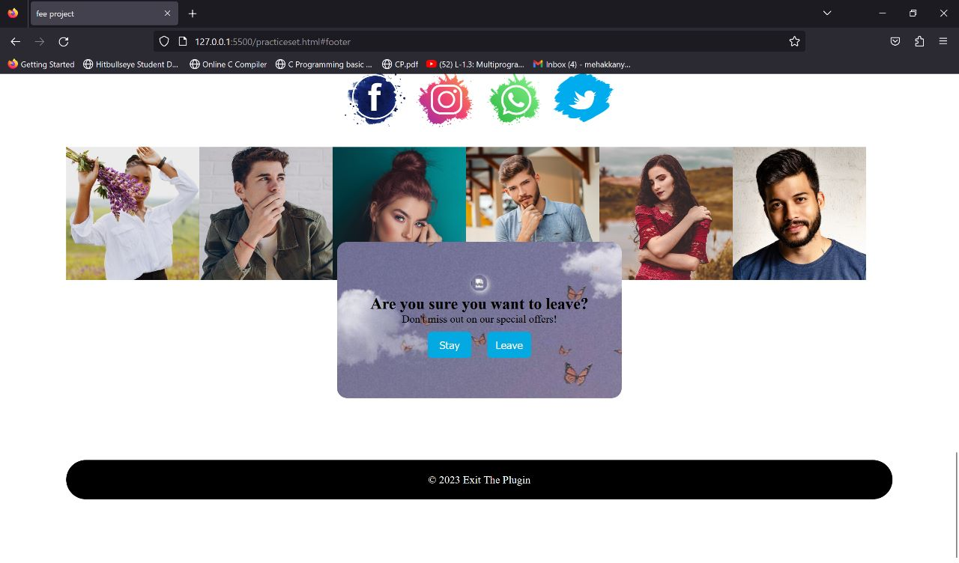

# REFERENCE

1. [**https://google.com/**](https://pixabay.com/)
2. [**https://youtube.com/**](https://opencolorio.org/)
3. [**https://gfg.com/**](https://heroicons.com/)
4. [**https://W3school.com/**](https://typescale.com/)